­­­Supporting Documentation for *Small Music* (2018)

Figure 1 (of 2): Website for *Small Music*

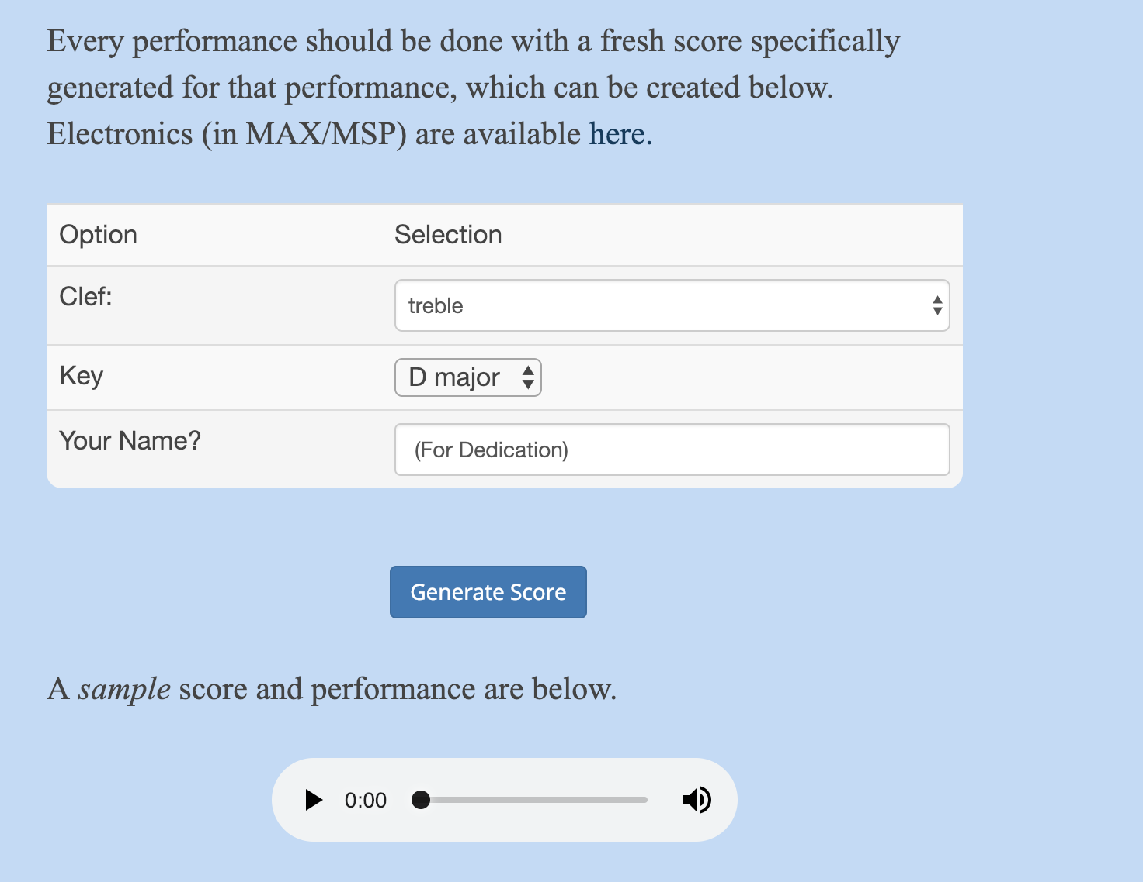

This web page hosts *Small Music* and provides the ability for the performer to have direct access to the output of the algorithmic composition process. Here you can select the key signature of the resulting piece, the clef that you are most comfortable reading, and insert your name for use in the dedication. The web page also links to the Max patch available for performers.

The web page is linked at the bottom of every *Small Music* score, at

www.<composer’s name>.com/smallMusic

Figure 2 (of 2): Patch for *Small Music*

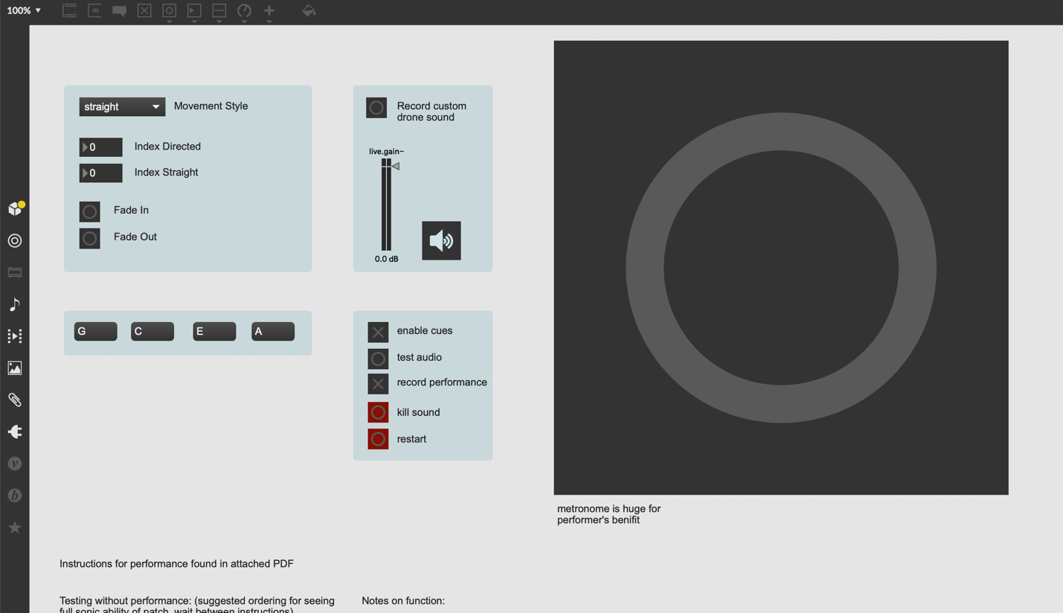

An image of the Max patch used to perform the piece. Instructions and controls are provided, as well as a large metronome for the performer to see from across the stage during performance. The patch can be operated by the performer with a foot pedal, or by an operator in the wings by pressing the space bar. Buttons to kill all sound, test the sound system, record the performance, and reset patch are all provided.